AI Agents

When talking about agents, we first need to define what an agent actually is. When describing an agent there are several factors that define it. The two most essential components to an agent are sensors which it can use to perceive the environment and actuators which are used to act upon the environment. Therefore many systems can be described as agents, even filehandling software which uses filedata or contents as its input (sensors) and writing or display capability as output (actuators).
Agents can only act on so called percepts, describing a single perceived input or percept squences which include all percepts the agents has collected over it's lifespan, but it cannot make any decisions based on data not found in these percepts. These actions are commonly called agents functions and match any given percept with an action executed by the agent. In most cases these matches would leave infinite results, therefore limitations must be put in place. When programatically implementing AI-agents a agent program is used which translates the mathematical description of the agent function into a concrete implementation within a environment
.
In most cases an agent that always picks the right choice is desired, these agents are referred to as rational agents which determine this “right” choice by considering the consequence of their action. To do this they take the state of the environment before and after an action was taken based on percepts and if this sequence has a desirable result the agents performance is considered good.
In order to achieve rationality in agents it has to follow four principles. Firstly, its measured performance defines its success, meaning success can only be determined by measuring the outcome of a sequence and comparing it to the previous environment state. Secondly, any prior knowledge the agent has of the environment, so including information relevant to the agents function, eg. a tree planting agent needs to know if there are already trees planted. Thirdly, the set of actions the agent can perform, this is critical to the task the agent needs to fulfill it cannot achieve a rational result when it does not have the capability to do so. Lastly the agents percept sequence, the more the agent has perceived over it's lifetime the more educated it's decision making will be.

The second kind of agent that is theoretically a possibility but mostly impossible to implement is a omniscient agent. These agents will already know the results of their actions and therefore will always use the correct action at any given situation. The difference between a rational and a omniscient agent is mostly that the rational agent maximizes its expected performance whereas a rational one actually maximizes performance. The problem with this approach is that the omniscient agent needs to know every outcome to its actions prior to actually doing them which is impossible to fulfill.
So to maximize a rational agents expected performance it needs to have as much data at its disposal as it needs to fulfill its task in the “right” way. To achieve this actions can be taken by the agent himself, these are sometimes called information gathering and describe the agent modifying its future percepts through current actions eg. the tree planting agent first looks around for any objects in the way or any already planted trees before starting to plant.
Furthermore it is very greatly increases the performance of a agent needs to b provided with the largest amount of autonomy possible and needed for its task. Meaning it should not rely to much n prior knowledge from its creator and rather learn through its percepts and compensate for the lack or falseness of prior information. To achieve this it needs to be provided with a set of base knowledge to start building its experience in the environment. These bis assistance is required for it to fulfill its task long enough to have enough experience to become fully independent.
(Russell & Norvig, 1995, pp. 35–40)

Environments
(Russell & Norvig, 1995, pp. 35–47)

First thing to note when going into detail about environments for artificial intelligence agents is that there is no difference between a “real” and an artificial environment, meaning an environment with no actually existing physical objects to consider. But rather how complex relation between the major three other points, performance measure, behavior of the agent and percept sequence is. And this complexity seems to have no correlation to whether the environment is “real” or “artificial” als many purely software related agents (search bots and crawlers) have very complex and rich domains to operate in. But to describe environments there are some properties which can be used. Most notably seven:

- observability: This describes whether the agent can detect the entire environment with its sensors or only parts of it. Though there are subcategories to this such as the “effectively fully observable environment” where the agent gets all necessary information about its actions from its sensors but does not detect the entire environment it's placed in.
- agent count: In environment the amount of other agents is highly relevant, usually the distinction is made between single and multiagent environments. The first variant is rather straight forward with only the environment to consider in actions. An environment is considered mulitagent when the decisions of any given agent are depended on other agents behavior eg. multiple tree planting agent planting trees in the same area the places they can plant are influenced by other agents that also plant trees. multiagent environments can furthermore be broken down into competitive mulitagent environments and cooperative ones, with our example above describing a cooperative one. In cooperative environments agents share the same goal and thus communication usually is adopted as a behavior to get the best expected performance. Competitive environment feature agents with conflicting goals eg. two agents playing chess. To avoid predictability in these cases it is usual that random behavior is adopted.
- determinabitliy: Environments can be further classified into deterministic environments, meaning environments which states are only modified by the agent and stochastic environments these habitats change their state independent of agent interaction. Most surroundings appear stochastic to the agent though due to their partially observable nature. These environments which are either not fully observable or not deterministic are called uncertain. It is not deterministic when every action taken can be described by its possible outcome but these outcomes have no possibilities that follow them.
- episodic or sequential: Episodic habitats are divided into single slices in which the agent only gets one precept and can take one action. The actions of the current slice are not determined by actions on previous slices though only on the current percept. Habitats considered sequential on the other hand have a carrythrough of actions, so an action taken is able to influence all future actions.
- dynamic nature: In dynamic environments the habitat can change during the agent's decision making process, which means it constantly requires a decision from the agent. If the surroundings are static the environment only changes after a decision is made by the agent.
- discrete nature: This describes how time effects the environment, every habitat where there are a finite number turns, independent of time (chess, most card and boardgames) are considered discrete. Continuous environments have constantly sweeping input values to consider though (music analyzing).
- Knowledge: This refers to how much the agent currently knows about the rules of its environment. So if the environment is known, the agent also knows all outcomes to its actions.

Artificial Intelligence Architectures:

There are several different ways to implement artificial intelligence regardless of the target environment.

Finite state machines:

State machines are one of the more popular approaches to AI in video games can mostly be attributed to their strengths. FSM are, as long as they stay at a certain size and are well structured and documented, easy to debug, programm and comprehend. In general finite state machines consist of three main components, states, transitions and inputs. States describe a set of instructions that will be completed as long as the state machine remains in it. Using inputs transitions into other states can be forced and tasks can be performed during transitions as well. Every FSM begins its cycle in a so called starting state and then transitions into other states based on inputs. Additionally state machines can be extended to further support events and a statelog to remember past states. This is very useful in regards to video games since AI in games usually implements behaviors for the agent as a state of the FSM. With the addition of a statelog previous tasks can be continued if it has been interrupted by an event. In addition to that multiple statemachine can be run on the same agent working on different taks, which is also possible in a hierarchical nature, with some state machines doing lower level tasks and other higher level ones. (Rabin, 2002, pp. 548–554)
There are downsides to finite state machines as well though. As the number of states increases the number of transitions also rises. This holds true especially if all states need to have a transition to every other state resulting in a quadratic growth of transitions.

There can also be additional difficulties adding new states into a already large statemachine, as is usually the case in games, since in the worst case logic for transitioning to the new state has to be added into every other state as well as the transitions themselves mus be created.(Mark, 2012)

Pathfinding

Pathfinding is one of the very essential parts of current video game artificial intelligence since it usually forms the basis for all later high level decision making eg. a bot needs to first be able to navigate the environment before it can interact with the player. To achieve this most pathfinding algorithms including traditional A* use precalculated representation of the current game environment. Using this precalulation which will be called worldmap or WM is then further used to mavigate the environment using simple constraints placed on the agent eg. maximum slope or jumpheight.(Graham, McCabe, & Sheridan, 2003, p. 60)

Pathfinding can be split into two general approaches directed and undirected pathfinding. The difference between these two is the planningphase, directed pathfinding uses a planningphase before starting the movement and undirected pathfinding does not, moving and making decisions based on the current knowledge. Directed approaches all use a system to calculate cost based the adolescent nodes, choosing the lowest cost path. In the case of video games this cost is commonly tied to distance. Cost calculation can be done in either a heuristic way whereas the cost from the net node towards the goal is considered or in a more direct approach, uniform cost search where always the lowest cost adjacent node is chosen. Though both can be combined for a more complete and efficient result. (Graham et al., 2003, p. 60,62)

A*

A* is a commonly used directed algorithm which uses a mixture of heuristic and uniform cost approach. Using a WM as its basis for decision making it explores nodes, that need to be created based on polygons provided by navigation meshes or area awareness systems. Using three additional values for each of these waypoints and two lists it decides which path if is the optional one, and can even backtrack if needed. The additional values are used to describe which path is the most likely to be both the most efficient and shortest. They are the following:

- g: describing the cost form the start node to the current node eq. the sum of g of all nodes traveled
- h: the heuristic value of the judged cost from the current node to the targetnode
- f : being the sum of both g and h respectively and is a rough value for how efficient a path is

In addition to the f,g,h it uses an open and a close list previously mentioned. Whereas the open list keeps a record of all nodes that are labeled unexplored, meaning not all the algorithm has not yet taken all nodes linked to the current one into consideration. The closed list however records all fully explored nodes. (Graham et al., 2003, p. 64)

These properties make A* very popular in video game development, most prominently AI in games since it's always guaranteed to find a path if one exists, examines fewer nodes than any other heuristic search algorithm and is also guaranteed to find the heuristically speaking shortest path possible.(Cui & Shi, 2011, p. 2)

As an example we will use this simple setup, with two obstacles in the way from the start to the endpoint. In this case diagonal movement is allowed. Each node is the same distance from its neighbors, with diagonal movement being more cost intensive due to Pythagoras Law. When starting out only two nodes are known and are in the open list. These get evaluated based on their f-cost with the node featuring the lowest cot being chosen for exploration.

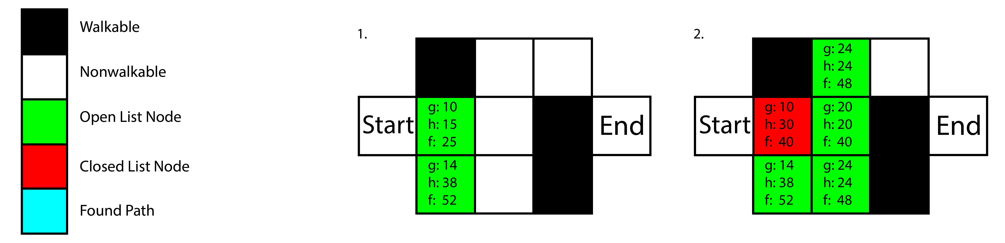

After having chosen the first Node to explore it is getting added to the closed list and the process repeats and the newly found nodes are added to the open list, ready for exploration. The same process as before starts and the lowest f-cost node is chosen for exploration, neighbors of that node are added to the open list and it is getting added to the closed list.
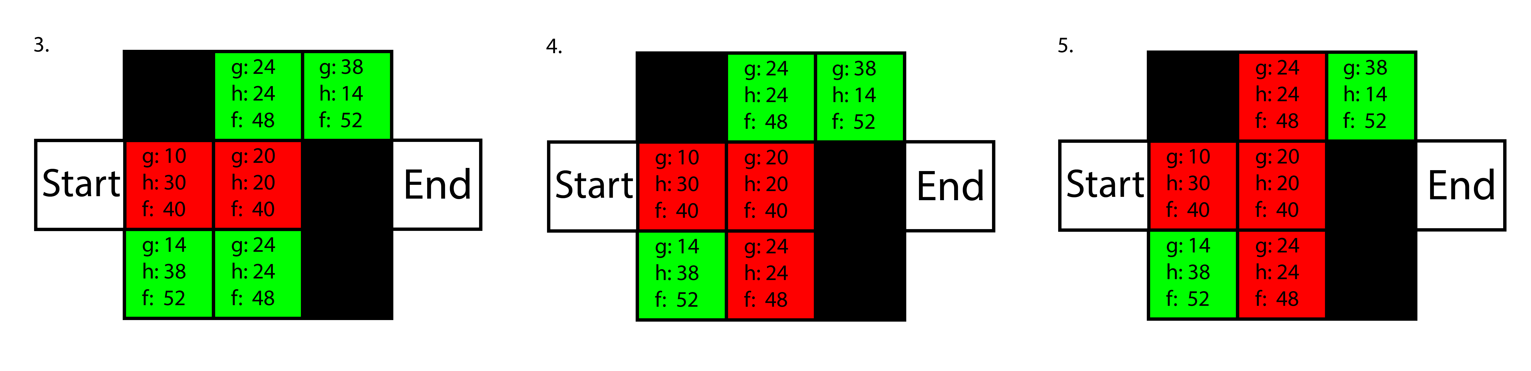

If there are two nodes with the same f-cost, h-cost is taken into account if that is the same as well, one is chosen at random and gets explored. This process is being repeated until a path is found.

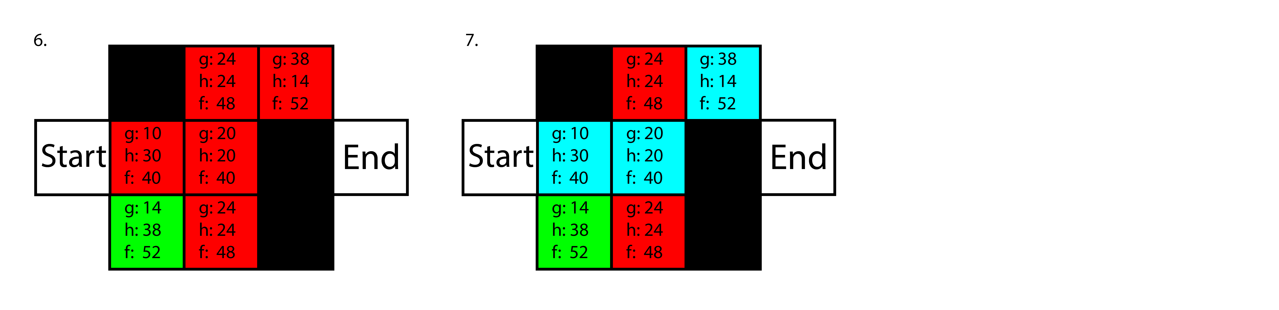

Problems with A*

The problem with the A* approach arises in dynamic environments due to its preprocessed nature which makes A* as efficient as it is in the first place. This makes realtime pathfinding very problematic. Since agents will still try to walk onto nodes that have been covered by dynamic objects resulting in unbelievable behavior. Realistic movement is also an issue since it is directly tied to the number of nodes used to calculate paths. Low noderesolution leads to movement with very visible cuts and corners. To fix this smoothing out the path using curves eg.splines or increasing node resolution are common practices. (Graham et al., 2003, pp. 67–68)
It also becomes very hard to handle in bigger environments with a high nodecount and multiple agents consuming vast amounts of CPU resources. This can lead to problems with user experience since freezes during path calculation and stutter might occur. (Graham et al., 2003, pp. 67–68) (Cui & Shi, 2011, p. 2)

To avoid problems created by dynamic objects alternatives have been developed, most notably D*. Which allows node costs to be dynamically created and edited during run time as the agent traverses the environment, thus allowing it to find paths based on this newly edited costs. But this also creates additional strain on the CPU. (Graham et al., 2003, p. 68) A variant of the D* algorithm is the DHPA* algorithm which as A* uses a build function to first build the WM. It is more memory heavy on its build phase but improves on traditional dynamic pathfinding in the search phase. It introduces an additional step in the buildphase using the Dijkstra algorithm to create costs for abstract nodes, thus the increased memory usage. Each abstract node includes a cluster of real nodes used for a* search. If changes occur in the environment rebuilding of nodes is only performed within a cluster, a limited space of nodes, to reduce impact on the CPU.
The search algorithm uses two steps to determine a path. It first runs ab abstract search, using the abstract cache created by the Dijkstra algorythm to find an abstract path. Then A* searches are performed in the abstract nodes to determine the optimal path. The connection between abstract nodes is handled using a path indices the refer to the following node on the optimal path calculated by the abstract search. (Kring, Champandard, & Samarin, 2010, pp. 2–3)
A different approach uses the time sensitive nature of video games to its advantage by limiting the search depth, meaning how far (distance/cost) the search is being calculated. This limit is aimed to enable calculation of a partial path within one time unit (frame) of the game and then moves the starting point to the newly calculated end and repeats until it reaches it's global goal. Due to this behavior the algorithm is able to react to changes in the environment and can also include risk integration adding additional cost to nodes based on how risky the path to be taken can be, to create a more human like path. (Leigh, Louis, & Miles, 2007, pp. 1–3)

When dealing with the increased computational cost there are also several approaches that can help limit the impact on the calculating system. One of them is to optimize the underlying data structure used for the search. For example to improve the search speeds and system impact for large search spaces a hierarchical approach can be used like HPA* or the above discussed more dynamically optimized DHPA* these split the search space into smaller chunks performing searches for each chunk separately. The improvement with this Method lies in its scalability meaning it can have multiple hierarchical layers (eg. Continents → Regions → Countries → States → Counties...).
This increases search speeds drastically with the addition of new hierarchical layers but at the possible cost of actual path efficiency. Since after a cluster transition the starting point within the new cluster might not be very efficient.
An Alternative to this method is to cut the number of nodes drastically by using a set of predetermined coordinated known as a waypoint graph giving the agents a defined path that can be used to travel. One can imagine this as a sort of street system where the agent enters at the nearest waypoint and then used the waypoint graph to find the most optimal way to reach is destination.
The use of a navigation mesh is also a common practice to speed up search using a set of convex 3D polygon to represent possible walkable surfaces. Movement occurs from one polygon to the other just like in the previous example using rectangular nodes but highly simplifying the process since the agent can move to the desired destination in a straight line once it has reached the polygon that houses this destination point. This is more efficient in both path length and computational effort compared to the waypoint graph discussed above.(Cui & Shi, 2011, pp. 2–3)

Aside form optimizing the searchspace for the algorithm there are other methods to limit the computaional impact. The heuristic function used to determine the A*s node costs has a large impact on computational power. For example using the Euclidean distance as a heuristic involves having to calculate two powers and one square root which is rather intense computationally speaking. Even though floating point numbers can be avoided to improve speeds, and the property of underestimating, meaning always getting the fastest path due to the fact it calculates the direct line between to points, there are alternatives such as the diagonal shortcut heuristic or the Manhattan Block heuristic which rely on subtraction and addition, which are much more performance friendly. Both of these variants overestimate in contrast to the Euclidean distance which can lead to a faster search, since the algorithm tends to explore less nodes. However there is no measure of how much overestimation is considered ideal at this point in time. (Leigh et al., 2007, pp. 2–3) (Cui & Shi, 2011, p. 3)

Further optimization can be made to the memory allocation of A* based algorithms which tend to allocate big amounts of memory space, when searching large worlds. So instead of allocating all memory needed to fulfill the requirements of the search, which is hard to determine since the outcome is not known. A dynamic way of dedicating memory is used where the minimum amount needed is first allocated and later expanded upon in case the search needs more memory. Other memory limiting options can be partial path calculations up to a certain threshold if no result is found the threshold is increased and another search is carried out.(Cui & Shi, 2011, pp. 3–4)

